☐ | Oral presentation
☐ | Poster presentation
☐ | No preference

Support Modification to Improve the Sulfur Tolerance of Ax/Y₂Z₅ for SCR of NO_{x} with H₂ (Type Your Title Here – Arial 12pt Bold)

T. J. Author¹ and R. S. Author-Two²*(Arial 10pt Bold and italics)

¹(Arial 10pt) Great University, Anytown, Postcode Country
²Fundamental Research Laboratory, Excellent Company, Site Location, Anytown, Postcode Country
*r.s.a-t@excompany.com (e-mail of the corresponding author and designated with a star)

Introduction
A variety of information may be provided to introduce the topic. Citations to the relevant prior literature are appropriate, [1] whether they are citations to the chemical problem or the techniques employed in the study [2,3]. Note the formatting of in-text citations and formatting for references in the Reference Section. Commonly accepted abbreviations should be employed. Examples of abbreviation formats include: 1000-4000 ppm, 2 – 5 wt% Pd / Al₂O₃, 50 m²/g, TOF = 4.26x10⁴ h⁻¹. All text should be in font Arial, size 11 pt with full justification. The document has margins: 2.0 cm Top, 2.0 cm Bottom, 2.0 cm Left, 2.0 cm Right.

Materials and Methods
This section serves as the “Experimental” section for laboratory studies. Brief descriptions of chemicals and equipment should be supplied, along with descriptions of experimental procedures, analytical tools and methods of data analysis. For studies, which are exclusively theoretical or computational, descriptions of relevant software packages, basis sets, data analysis tools, etc. should be supplied.

Results and Discussion
Brief descriptions of key results should be supplied along with discussion of relevant conclusion, mechanistic insights and other inferences. Text within the figure, if any, should not be sized less than 8pt font. It is best to utilize conventional formats for artwork (*.tif, *.jpeg, *.gif etc and Microsoft Office-compatible software).
After presentation of data, one would normally describe it and its relevance to the problem under study. The total size of the abstract should not exceed two pages in the format of this document.

Conclusions
Authors should briefly highlight industrial and/or fundamental significance of the work.

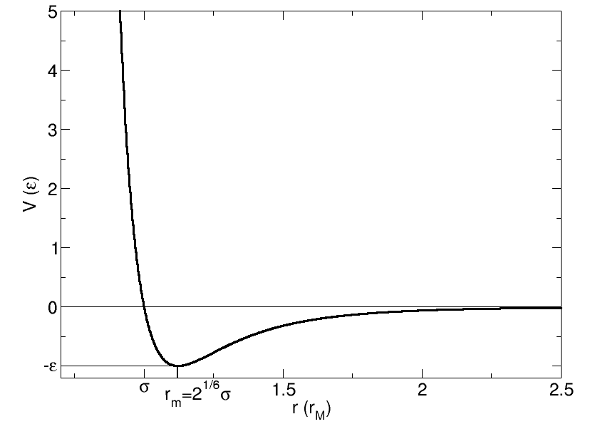

Figure 1. A graph of potential energy versus distance for the 12-6 Lennard-Jones potential (font Arial, size 10 pt may be used here).

References (font Arial, size 10 pt may be used here)
- Anonymous, Topics in Catal. 98 (2000) 26.
- Knudsen, K.G., Cooper, B.H., and Topsoe, H. Appl. Catal. A: General 189 (1999) 205.
- Allgeier, A.M., and Duch, M.W. in “Chemical Industries (Catalysis of Organic Reactions” (M.E. Ford, Ed.) Vol. 82 p. 229. Marcel Dekker, New York, 2001.

